Draft ETSI GS PDL 026 V1.0.0 (2024-03)
PDL in Settlement of Usage Based Services;
Permissioned Distributed Ledger;
Group Specification PDL 026
Release 1

Disclaimer
The present document has been produced and approved by the Permissioned Distributed Ledger (PDL) ETSI Industry Specification Group (ISG) and represents the views of those members who participated in this ISG.
It does not necessarily represent the views of the entire ETSI membership.
Group Specification

Reference
DGS/PDL-0026_Settlmt_UB_serv

Keywords
Distributed Ledger, Architecture

ETSI
650 Route des Lucioles
F-06921 Sophia Antipolis Cedex - FRANCE

Tel.: +33 4 92 94 42 00 Fax: +33 4 93 65 47 16

Siret N° 348 623 562 00017 - APE 7112B
Association à but non lucratif enregistrée à la
Sous-Préfecture de Grasse (06) N° w061004871

Important notice
The present document can be downloaded from:
https://www.etsi.org/standards-search
The present document may be made available in electronic versions and/or in print. The content of any electronic and/or print versions of the present document shall not be modified without the prior written authorization of ETSI. In case of any existing or perceived difference in contents between such versions and/or in print, the prevailing version of an ETSI deliverable is the one made publicly available in PDF format at www.etsi.org/deliver.
Users of the present document should be aware that the document may be subject to revision or change of status. Information on the current status of this and other ETSI documents is available at https://portal.etsi.org/TB/ETSIDeliverableStatus.aspx
If you find errors in the present document, please send your comment to one of the following services:
https://portal.etsi.org/People/CommiteeSupportStaff.aspx
If you find a security vulnerability in the present document, please report it through our
Coordinated Vulnerability Disclosure Program:
https://www.etsi.org/standards/coordinated-vulnerability-disclosure
Notice of disclaimer & limitation of liability
The information provided in the present deliverable is directed solely to professionals who have the appropriate degree of experience to understand and interpret its content in accordance with generally accepted engineering or
other professional standard and applicable regulations.
No recommendation as to products and services or vendors is made or should be implied.
No representation or warranty is made that this deliverable is technically accurate or sufficient or conforms to any law and/or governmental rule and/or regulation and further, no representation or warranty is made of merchantability or fitness for any particular purpose or against infringement of intellectual property rights.
In no event shall ETSI be held liable for loss of profits or any other incidental or consequential damages.

Any software contained in this deliverable is provided "AS IS" with no warranties, express or implied, including but not limited to, the warranties of merchantability, fitness for a particular purpose and non-infringement of intellectual property rights and ETSI shall not be held liable in any event for any damages whatsoever (including, without limitation, damages for loss of profits, business interruption, loss of information, or any other pecuniary loss) arising out of or related to the use of or inability to use the software.
Copyright Notification
Reproduction is only permitted for the purpose of standardization work undertaken within ETSI.
The copyright and the foregoing restrictions extend to reproduction in all media.

© ETSI 2024.
All rights reserved.
Contents
Intellectual Property Rights 5
Foreword 5
Modal verbs terminology 5
Executive summary 5
Introduction 6
1 Scope 7
1.1 Introduction 7
1.2 In scope 7
1.3 Out of scope 7
2 References 7
2.1 Normative references 7
2.2 Informative references 7
3 Definition of terms, symbols and abbreviations 8
3.1 Terms 8
3.2 Symbols 9
3.3 Abbreviations 9
4 Management of Data in a multi-domain environment 9
4.1 Introduction 9
4.2 Sources of data 10
4.2.1 Single-Sourced data 10
4.2.2 Multi-Sourced data 10
4.3 Characteristics of Data 11
4.3.1 Introduction 11
4.3.2 Commercial value 11
4.3.3 Cost of transacting 11
4.3.4 Volume of data 11
4.3.5 Processing of Per-Item data and Aggregated data 12
4.3.6 Frequency of Reconciliation and Settlement 12
4.3.6.1 Term-based 12
4.3.6.2 Event-based 12
5 PDL Nodes in a multi-domain environment 13
5.1 Introduction 13
5.2 Number of nodes 13
5.3 Ownership of nodes 13
5.4 Location of nodes 13
5.5 Chain type 13
5.6 Data Sovereignty 14
5.7 Local legislation 14
6 Rating 14
7 Reconciliation 15
7.1 Definition of Reconciliation 15
7.2 Reconciliation prior to invoicing 15
7.3 Reconciliation after invoicing 16
8 Invoicing 16
8.1 Introduction to Invoicing 16
8.2 Invoicing occurrence 17
8.3 Invoice contents 17
8.4 Buyer-Seller entity multiplicity 17
8.5 Additional requirements related to Invoicing in a PDL enabled environment 18
9 Discrepancy and Dispute Management 18
9.1 Introduction to Discrepancies and Disputes 18
9.2 Dispute Threshold 19
9.3 Dispute Resolution 19
9.4 Finality 20
10 Settlement 20
10.1 Definition of Settlement 20
10.2 Payment 20
10.3 Netting 20
10.4 Netting and Payment process diagram 20
Annex A (informative): Change history 22
History 23

Intellectual Property Rights
Essential patents
IPRs essential or potentially essential to normative deliverables may have been declared to ETSI. The declarations pertaining to these essential IPRs, if any, are publicly available for ETSI members and non-members, and can be found in ETSI SR 000 314: "Intellectual Property Rights (IPRs); Essential, or potentially Essential, IPRs notified to ETSI in respect of ETSI standards", which is available from the ETSI Secretariat. Latest updates are available on the ETSI Web server (https://ipr.etsi.org/).
Pursuant to the ETSI Directives including the ETSI IPR Policy, no investigation regarding the essentiality of IPRs, including IPR searches, has been carried out by ETSI. No guarantee can be given as to the existence of other IPRs not referenced in ETSI SR 000 314 (or the updates on the ETSI Web server) which are, or may be, or may become, essential to the present document.
Trademarks
The present document may include trademarks and/or tradenames which are asserted and/or registered by their owners. ETSI claims no ownership of these except for any which are indicated as being the property of ETSI, and conveys no right to use or reproduce any trademark and/or tradename. Mention of those trademarks in the present document does not constitute an endorsement by ETSI of products, services or organizations associated with those trademarks.
DECT™, PLUGTESTS™, UMTS™ and the ETSI logo are trademarks of ETSI registered for the benefit of its Members. 3GPP™ and LTE™ are trademarks of ETSI registered for the benefit of its Members and of the 3GPP Organizational Partners. oneM2M™ logo is a trademark of ETSI registered for the benefit of its Members and of the oneM2M Partners. GSM® and the GSM logo are trademarks registered and owned by the GSM Association.

Foreword
This Group Specification (GS) has been produced by ETSI Industry Specification Group (ISG) Permissioned Distributed Ledger (PDL).

Modal verbs terminology
In the present document "shall", "shall not", "should", "should not", "may", "need not", "will", "will not", "can" and "cannot" are to be interpreted as described in clause 3.2 of the ETSI Drafting Rules (Verbal forms for the expression of provisions).
"must" and "must not" are NOT allowed in ETSI deliverables except when used in direct citation.

Executive summary
The application and use of PDL in settlement of usage-based services is discussed and analysed resulting in specifications, requirements and recommendations related to management of data sources, processes and actions related to commercial and commercial affecting attributes. The present document is broken down to three main parts: Data management, PDL node management and Settlement process, including Rating of usage records, discrepancy and dispute management and reconciliation, invoicing, and commercial settlement.

Introduction
Usage-based services are consumed in a manner that can be measured by units of measurement such as time, distance, speed, volume, temperature, pressure, and many other measurable attributes. An example of a measurable service would be a telephone call where the duration, destination and quality of the call can all be measured (each with a certain degree of accuracy). An in-depth discussion of measurable attributes related to the ICT sector can be found in MEF-74 "Commercial Affecting Attributes" [i.1].
A commercial rate can be applied to a measurement of a service giving the measurement a commercial value. Taking the example of a telephone call: Suppose the agreed rate between a buyer and a seller of telephony service is USD 0,50 per minute of call destined to the USA, and the buyer places a call whose duration is measured to be three minutes, the usage-based fee for such call would be USD 1,50.
A similar logic can be applied to other services in most areas of life:
- Household water consumption and the municipal water supply service.
- Agricultural produce and the wholesale/retail supply chain from the field to the consumer.
- Data Centre computation and storage capacity and the users of such services.
- Toll road usage, the toll road operators and the drivers of vehicles on such reads.
- And many more.
Once a record of usage has been established it may go through commercial processes of:
- Rating (see clause 6 Rating herewith)
- Dispute management and Reconciliation (see clauses 7 Reconciliation and 9 Discrepancy and Dispute Management herewith)
- Invoicing (see clause 8 Invoicing herewith)
- Settlement (see clause 10 Settlement herewith)
Usage-based services differ from other consumables in that the amount of use of such service is not known until it had been actually used. This affects the way such services are billed for.
Payment for services may be performed in advance (when the service will only become available to the buyer after payment had been made) or in arrears (where payment is made after the service has been consumed).
Regular services, that are not usage based, would be billed the same amount whether they are billed in advance or in arrears (e.g. some bridge or tunnel tolls are charge upon entry ad some upon exist). Usage-based services, however, will be treated differently if they are charged in advance, where the buyer will buy some balance in advance and will be able to use such service until their balance depletes (e.g. a pre-paid calling card) or in arrears, where the buyer pays for whatever service was consumed (e.g. a monthly telephone bill).
The present document discusses the application and use of PDL in settlement of usage-based services. It defines specifications, requirements and recommendations related to management of data sources, processes and actions related to commercial and commercial affecting attributes of such services.
The present document is broken down to three main parts: Data management, PDL node management, and Settlement process, including Rating of usage records, discrepancy and dispute management and reconciliation, invoicing and commercial settlement.

1 Scope

1.1 Introduction
The present document discusses and specifies the processes and methods of utilizing PDL in settlement of usage based services.

1.2 In scope
- Definitions of processes.
- Definitions and requirements related to PDL node management.
- Definitions of commercial and data management terms and operational methods.
- Definitions and specifications of dispute resolution stages and processes.

1.3 Out of scope
- Specific reconciliation and dispute resolution algorithms.
- Commercial agreements.
- Commercial data.

2 References

2.1 Normative references
References are either specific (identified by date of publication and/or edition number or version number) or non-specific. For specific references, only the cited version applies. For non-specific references, the latest version of the referenced document (including any amendments) applies.
Referenced documents which are not found to be publicly available in the expected location might be found at https://docbox.etsi.org/Reference.
NOTE: While any hyperlinks included in this clause were valid at the time of publication, ETSI cannot guarantee their long term validity.
The following referenced documents are necessary for the application of the present document.
Void.

2.2 Informative references
References are either specific (identified by date of publication and/or edition number or version number) or non-specific. For specific references, only the cited version applies. For non-specific references, the latest version of the referenced document (including any amendments) applies.
NOTE: While any hyperlinks included in this clause were valid at the time of publication, ETSI cannot guarantee their long term validity.
The following referenced documents are not necessary for the application of the present document but they assist the user with regard to a particular subject area.
[i.1] MEF Forum, MEF-74, December 2018: "Commercial Affecting attributes".
[i.2] ETSI GS PDL 012 (V.1.2.1): "PDL Reference Architecture".
[i.3] ETSI GS PDL 022 (V.1.1.1): "PDL in Supply Chains".

3 Definition of terms, symbols and abbreviations

3.1 Terms
For the purposes of the present document, the following terms apply:
billing: commercial process of invoicing, reconciliation, and settlement of amounts due by Buyer, Seller or bidirectional trading partners
NOTE: See MEF 74 [i.1].
buyer: entity that buys a service from a Seller of which it is an immediate neighbour in the Supply Chain
Call Details Record ("CDR"): digital record containing information related to a telephone call traversing a telephone network
commercial agreement: agreement between two parties allowing for buying services, selling services between them or both
compute: act of manipulating data or acting based on data using a computing resource
connectivity: act of transporting data through space
data: in the context of the present document data is information related to the characteristics and usage of services
data service: service that combines one or more of the following:
- Connectivity service
- Compute service
- Storage service
domain: group of ICT elements administered and operated by an entity and subject to specific rules, regulations and procedures
gas cost: cost of performing a blockchain transaction
Internet of Things ("IoT"): network of physical objects that are embedded with sensors, software and other technologies for the purpose of connecting and exchanging data with other devices and systems over the internet
invoicing: process in which the Seller generates and sends an invoice to the Buyer for the amount stipulated by an agreement and based on utilization information and SLA or other credits as applicable based on agreement
Multi-domain environment: ICT environment where multiple domains exist and are managed by different entities
Netting: subtracting amounts due by two parties to each other resulting in a net amount owed by one party to the other and a zero amount owed by the other party
rating: application of a commercial rate to a usage record
reconciliation: process of reaching agreement in case of a dispute
NOTE: See MEF 74‎ [i.1]‎.
seller: entity that sells goods or a service to a Buyer of which it is an immediate neighbour in the Supply Chain
settlement: transfer of monetary funds between parties based on billing and reconciliation
Service Level Agreement (SLA): contract between the Buyer and Seller specifying the service level commitments and related business agreements and penalties related to failure to meet such service level for a service
supply chain: collection of entities that in combination deliver one or more goods or end-to-end services through bilateral agreements
transaction point: a physical or virtual meeting place between a buyer and seller where transactions are being performed

3.2 Symbols
Void.

3.3 Abbreviations
For the purposes of the present document, the following abbreviations apply:
CDR Call Details Record
CPU Central Processing Unit
DLT Distributed Ledger Technology
ETSI European Telecommunications Standards Institute
GDPR General Data Protection Regulation
GUI Graphical User Interface
ID Identification/Identity Document
ICT Information and Communications Technology
IoT Internet of Things
ISG Industry Specification Group
MBPS MegaBits per Second
MEF MEF Forum (Formerly known as “Metro Ethernet Forum”)
PDL Permissioned Distributed Ledger
PoC Proof of Concept
SLA Service Level Agreement
USD United States Dollar
VAT Value Added Tax

4 Management of Data in a multi-domain environment

4.1 Introduction
When handling data in a multi-domain environment the following aspects should be considered:
The source of data:
- How is it measured?
- By whom?
- Can the data be measured by more than one entity or in more than one point?
The different characteristics of data:
- The direct or derived commercial value of the data or that the data defines/describes.
- The volume of data.
- The cost of transacting the data.
The following clauses discuss the above in detail.

4.2 Sources of data

4.2.1 Single-Sourced data
In many instances there is only a single source of data. In such events even when multiple parties use such data, they are all dependent on that single source and in the event of dispute the different parties cannot provide alternative data to contradict that single source of data. There may be disputes on interpretation of data or on assignment of a commercial value to such data, but the data itself cannot be disputed.
EXAMPLE: When a mobile device is roaming from its home operator to a hosting operator the measurement of call duration and data consumption is done by the hosting operator. The roaming user and the home operator both do not have the ability to measure call duration or data consumption thus are unable to provide alternative measurements to contradict the measurements of the hosting operator. There may be a dispute over the rates applied to the measured data (e.g. the home operator may argue that the hosting operator has applied a higher per-minute or per-kilobit rate than agreed) but there is no way for the home operator to prove a possible claim that the duration of calls or volume of data consumed by the roaming user was different than the measurements made by the hosting operator.

4.2.2 Multi-Sourced data
When data can be measured by more than one entity and/or in more than one location, it is considered Multi-Sourced. There may be discrepancies between data generated for a certain event by different sources. The reasons for such discrepancies can be:
- Different measurement methods.
- Different Measurement equipment/calibration.
- Measurements at different points along the path of flow of information/matter which may be subject to data loss/corruption.
- Others.
When different entities can present different measurements for the same event - each entity may dispute the measurements presented by the other entity. In such event the parties may choose to go through a dispute resolution process and reconcile.
EXAMPLE: When a telecom carrier routes an international telephone call to another telecom carrier each carrier generates a Call Details Record ("CDR") for that call. The CDR includes certain data such as call duration, originating number of the call, destination number of the call. Such attributes determine the commercial value of that call: the monetary amount that the sending carrier is obligated to pay to the receiving carrier for extending the call to its destination. There may be instances where the CDRs generated by the sending carrier and the receiving carrier differ (e.g. the call duration does not match). In such instances the carriers may debate until they reconcile and agree on a value (or a monetary amount) to be used for settlement of the CDR.
Figure 1 herewith depicts the differences between Single-Sourced and Multi-Sourced data.
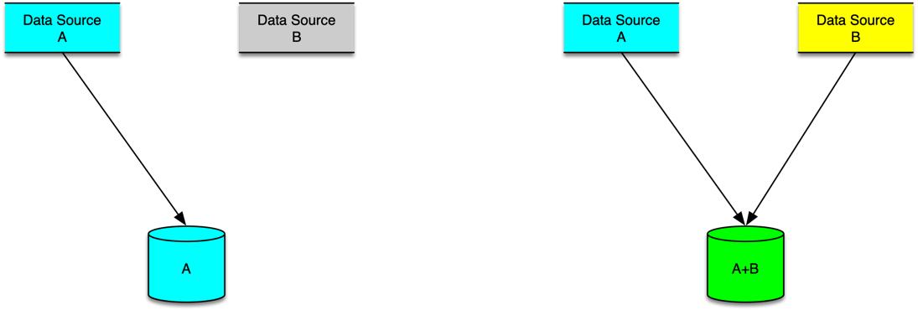
Figure 1: Single and Multi-sourced data

4.3 Characteristics of Data

4.3.1 Introduction
Measured data may have multiple characteristics that may affect the way data is measured, collected, stored, calculated, reconciled and settled.

4.3.2 Commercial value
The commercial value of measured data may have effect on the way the data is measured (frequency of measurements, level of accuracy/tolerance, number of measurement points) and the way it is reconciled and settled. The commercial value of a transaction can range from a fraction of a cent per transaction (e.g. IoT transactions) to hundreds or thousands of Euro/Dollar per transaction (e.g. trading precious metals, wholesale energy consumption, car rentals).
As a general rule, though not mandatory, the higher the commercial value of the data - the more accurate the measurement should be and the more measurement points there should be.
MEF-74 [i.1] defines attributes that affect the commercial value of measured data with focus on MEF services (Carrier Ethernet and Layer-3). Most of the commercial affecting attributes defined in that document may apply to other ICT services.
EXAMPLE: When shipping crude oil from the wells to the refinery it is likely that the amount being shipped is measured both at the well and at the refinery by two separate entities (and possibly at additional points along the route such as shipping loading docks, etc.), whereas in the event of IoT data is often only measured at one point. By applying multiple measurement points the entities involved in crude oil supply chains (well operators, pipeline operators, ship operators, refineries etc.) can apply a commercial value to the crude oil traversing the supply chain and settle the payments between themselves. Note that different commercial values may be applied to the crude oil as it traverses the supply chain. E.g. the commercial value of crude oil off-loaded from a ship may be higher than the commercial value of the crude oil when it was loaded to the ship, as it now includes the cost of shipping, insurance, tax etc. Such commercial value is agreed between the buyer and seller at each transaction point along the way, and may also be subject to regulations, tax, and other levies.
[R1] The commercial value of goods SHALL be agreed between each pair of buyer and seller along a supply chain.
[D1] In a PDL enabled supply chain the commercial agreements between buyers and sellers SHOULD be implemented using a smart contract.

4.3.3 Cost of transacting
Transacting data incurs costs such as cost of measurement, cost of storage, cost of processing and cost of energy required to store and process such data. When PDL is involved the cost of transaction may grow compared to traditional transaction costs because of the distribution of nodes, networking costs and cost of consensus algorithm in use (also known as "gas cost").
[D2] For proper commercial value assessment the cost of transaction SHOULD be measurable and known.

4.3.4 Volume of data
The volume of data generated by measurements varies by use-case. Certain transactions occur frequently and generate huge amounts of data (e.g. IoT, wholesale telephone calls, inter-bank monetary transactions) while other transactions occur less frequently thus generating less transactional data (e.g. car-rental).
[R2] PDL platforms SHALL be capable of handling the volume of data generated by the participating nodes.

4.3.5 Processing of Per-Item data and Aggregated data
Depending on factors of commercial value of a transaction, cost of transacting and volume of data, processing of data may be performed in a discrete manner (processing each transaction by itself) or in an aggregated manner (aggregating multiple transactions and processing the aggregate).
Table 1 describes the considerations related to the method of processing such data.
Table 1: Per-Item and aggregated reconciliation
 | Per-Item processing | Aggregate processing
Reconciliation | Each record is reconciled and processed discretely. | Consent on the total aggregated value. Can not reconcile each record of data.
Benefits | Full visibility and clarity on all aspects of reconciled data. | Fast reconciliation based (primarily) on commercial value.
Disadvantages | Slow. Resource intensive. Cost of transacting may reduce commercial profitability. | Actual data is not reconciled, and source of discrepancy remains in place (or left unknown).
Suitable for | Low volumes of data where the commercial value of the data is >> the cost of the transaction. | High volumes of data where the commercial value of each item of the data is << the cost of the transaction.

4.3.6 Frequency of Reconciliation and Settlement

4.3.6.1 Term-based
Reconciliation and settlement may occur on pre-defined intervals such as a monthly, weekly, hourly basis. The frequency is related to attributes such as:
- The commercial agreements in place between the stakeholders of the transactions. E.g. Utility bills are typically settled on a monthly or bi-monthly basis regardless of the frequency at which the utility suppliers measure the usage.
- The duration of the events being measured. It would not make sense to reconcile at intervals shorter than the duration of the events being measured. E.g. when reconciling CDRs (see clause 4.2.2 above) it would make sense to reconcile and settle at daily intervals or longer, considering that the average duration of a telephone call is 5-10 minutes and on occasion (e.g. a conference call) calls may stretch for one or two hours, but is highly unlikely to span more than a day.
[D3] Term-based PDL enabled reconciliation SHOULD be performed at intervals longer than the duration of the events being reconciled.
In a term-based reconciliation environment the data (e.g. volume of water or energy being consumed by a household during the billing period; number, duration and destination of calls made by a user during a billing period) is being measured and recorded during the billing period and summarized, reconciled, and transacted at said predefined intervals.

4.3.6.2 Event-based
Reconciliation and settlement may occur based on events such as:
- Specific commercial transactions. E.g. buying a theatre ticket generates an immediate reconciliation and settlement between the ticket seller and buyer and triggers generation of the actual ticket (be it a paper ticket or an electronic document).
- Certain conditions. E.g. A vehicle crossing a toll gate and paying the required toll.
- Threshold being reached. E.g. A consumer's credit limit had been reached and the consumer is required to top-up their credit to continue consuming the service.

5 PDL Nodes in a multi-domain environment

5.1 Introduction
The architecture and topology of PDL nodes and networks is discussed thoroughly in ETSI GS PDL 012 [i.2] and ETSI GS PDL 022 [i.3].
This clause further expands the concepts defined therein with specific focus on settlement of usage-based services in a multi-entity environment.

5.2 Number of nodes
In most PDL scenarios there will be at least one node per participant in any chain such participant is part of, however there may be unique cases where all participants are using a single node. This is typically an interim transitional phase when establishing a PDL platform when the focus is on developing applications and PoCs in pre-production environments.
However, in a production system there has to be at least one node for each participant in a chain.
[R3] There SHALL be at least one node per transacting participant in a chain that performs reconciliation and settlement.
Some chain types mandate the inclusion of non-transacting nodes for the proper operation of such chain.
[O1] There MAY be one or more neutral nodes operated by non-transacting entities in a chain.

5.3 Ownership of nodes
[O2] Nodes MAY be owned by any entity as long as all participating entities can gain unbiased access to all required functions.
[R4] An entity owning a node SHALL provide unbiased access to all required functions to all participants in the chain.
[O3] Access to certain administrative functions on a node MAY be limited to specific entities for operational purposes regardless of ownership of such node.
[R5] Since access to data on all PDL nodes is unbiased, confidential data or data subject to specific privileges (e.g. GDPR) SHALL be properly encrypted.

5.4 Location of nodes
[O4] Nodes MAY be located on premisses of a participating entity, in a private cloud and on public cloud.
[R6] The location of a node SHALL comply with corporate policies and local legislation where applicable.

5.5 Chain type
[R7] Chain type SHALL be agreed by all participating entities.
[O5] Subject to [R7] The participating entities MAY agree to use any chain type, be that private, public or side chain, and any consensus mechanism.

5.6 Data Sovereignty
[R8] The chain type, location and ownership of nodes SHALL meet all jurisdictional regulatory requirements and all data sovereignty requirements defined and agreed between the participating parties.

5.7 Local legislation
[R9] The chain type, node ownership, node locations and implemented applications and smart-contracts SHALL comply with local legislations in all jurisdictions where such nodes and entities are operated.
An example of such local legislation is GDPR compliance.

6 Rating
For the purpose of the present document, the term 'rate' represents the monetary value of the unit of measurement of a service. For example, 5 cents (monetary value) per minute of use (unit of measurement) of a service; 1 USD per mile a service traverses; 0,05 cent per CPU cycle consumed by a service, etc.
Rating is the act of application of a rate to a service. Based upon agreed billing interval, utilization records for said interval are matched with and multiplied by the agreed upon contracted rates yielding rated utilization records. These records are then fed into the invoicing process. E.g., two telephone operators agree that the rate for terminating a telephone call in the USA is 5 USD cents per minute. They also agree on a monthly billing interval occurring on the last second of the last day of each month. The cumulative duration of calls destined to the USA that one carrier had sent to the other carrier is measured throughout the entire month and counted on the last second of that month and turned out (for the purpose of this simplified example) to be exactly one million minutes. By multiplying the measured cumulative duration (1 million minutes) by the agreed upon and contracted rate of 5 USD cents per minute the total due amount sums up to 1 000 000 minutes x 0,05 USD/minute = 50 000 USD.
[R10] A Seller SHALL rate utilization records according to agreed-upon and contracted rates between the Seller and the Buyer.
The Buyer and Seller may add clauses to their agreement that apply certain discounts or penalties when certain conditions are met. E.g. in the example above the Buyer and Seller may agree on a volume discount scheme such that any minute in excess of 800 000 minutes is billed at a rate of 4 USD cents per minute rather than the full price of 5 USD cents per minute. In such case the calculation shall look as follows: 800 000 minutes x 0,05 USD/minute + 200 000 minutes x 0,04 USD/minute = 48 000 USD. Another example may involve data connectivity service provided by a Seller to a Buyer, that is subject to SLA penalties if the service quality drops below a certain level. In such event the Buyer may be eligible to receive SLA credits from the Seller. Suppose such service is rated at USD 1 per MBPS of maximum usage during a calendar month and the measurement of the usage during such month was 1,000 MBPS yielding a monthly fee of 1 000 MBPS at 1 USD per MBPS/Month = USD 1 000. However, if during said month the service had suffered certain intermittent outages that were measured and recorded and, according to the SLA signed between the Buyer and Seller, the Buyer is eligible to a credit worth USD 100 for that month.
NOTE: The methods of measurement and calculation of such credits are out of scope of the present document.
In such case the total due amount will be USD 1 000 (based on rating) minus 100 (credit amount) = USD 900.
[O6] The rating process MAY include application of discounts and/or penalties based on volume or type of data transactions or events as mutually agreed by both parties.
[D4] When the data is processed through a PDL platform the rating SHOULD be performed using a smart-contract.

7 Reconciliation

7.1 Definition of Reconciliation
Reconciliation is defined, for the purposes of the present document, as the process of reaching agreement on the amount to be settled between neighbouring entities in the Supply Chain (i.e. Buyer and Seller).
[O7] Reconciliation MAY occur prior to or after issuance of an invoice.
In the event there is only a single source of data as described in clause 4.2.1 Single-Sourced data, reconciliation is based on that source alone. In absence of other data that may contradict that single source of information, the ability of parties other than the one performing the measurements to dispute the amount requested by the Seller is limited. Such parties may dispute the rating (i.e. the rate applied to the measurements) but not the measurement itself. Example: Consider a scenario where the Seller is the only party performing measurements (i.e. in a mobile roaming scenario measurement of the data consumption of the roaming user is performed only by the hosting mobile operator). In such scenario the buyer (be that the home mobile operator or even the mobile user itself) is unable to dispute the volume of data stated by the hosting operator but is still able to check if the rate that was applied by the hosting operator per unit of data was indeed according to the agreed upon roaming rate between the home operator and the hosting operator. In the event that the Buyer suspects that a wrong rate was applied - it may dispute the rating and negotiate with the seller towards reconciliation.
Reconciliation may involve resolution of disputes and discrepancies between the Buyer and the Seller. Several methods and approaches to dispute resolution are discussed in clause 9 Discrepancy and Dispute Management).
In the event there are multiple sources of data as described in clause 4.2.2 Multi-Sourced data, several scenarios may be considered and are summarized in Table 2 below:
Table 2: Reconciliation with Multi-Sourced data
 | All measurements are identical | Different measurements by different sources
No dispute on rating | Automatic reconciliation and rating | Reconcile measurements
Rating disputed | Reconcile rating | Reconcile measurements  Reconcile rating

7.2 Reconciliation prior to invoicing
Supply chain partners may prefer to reconcile their records prior to issuance of an invoice. The benefit of such approach is it reduces the overheads of issuing credit notes if discrepancies are found between the rated records of those parties. However, this option requires the Buyer and Seller to coordinate their respective business processes, align their data models, and spend the efforts to compare the records/data rather than the invoices. Such coordination is often performed using a neutral platform that offers the ability to:
- Each party to upload its respective data/records.
- An algorithm that identifies matching records coming from different sources.
- A GUI presenting the data in a manner that allows comparison of records, identification of discrepancies and reconciliation.
- Generation of billing statements that include reconciled records that are ready for invoicing.
- Each party may download such billing statements and use them to generate undisputed invoices (Seller) and verify and approve such invoices (the Buyer).
[D5] PDL SHOULD be used by such platform as it offers the disintermediation and neutrality requirements of such platform.

7.3 Reconciliation after invoicing
Albeit the operational benefits of reconciliation prior to invoicing, many Buyers and Sellers, likely the majority of both, are still using the more traditional way of reconciliation:
- The Seller issues an invoice based on their measurements, ratings, SLA monitoring, and sends it to the Buyer.
- The Buyer calculates their expected due amount based on their own usage records, SLA monitoring and rating.
- The Buyer verifies the invoice and compares it with their expected due amount calculated in step "b" above.
- If a discrepancy is found the Buyer opens a dispute with the Seller and both parties engage in a manual reconciliation process until they reach an agreement on the final due amount. Such process may stretch over weeks and months during which payment is held.
- If required - the Seller sends a credit or debit note to the Buyer to balance the difference from the original invoice.
- The Buyer pays the invoice minus any amount in a credit note or plus any amount in a debit note.
Figure 2 describes how a Buyer can estimate the amount it will be charged by the Seller through applying the business logic stipulated in the agreement with the Seller on the utilization records and SLA records it has stored in its own data repositories. The amount may differ from the amount actually invoiced by the Seller, which may trigger a dispute resolution process.
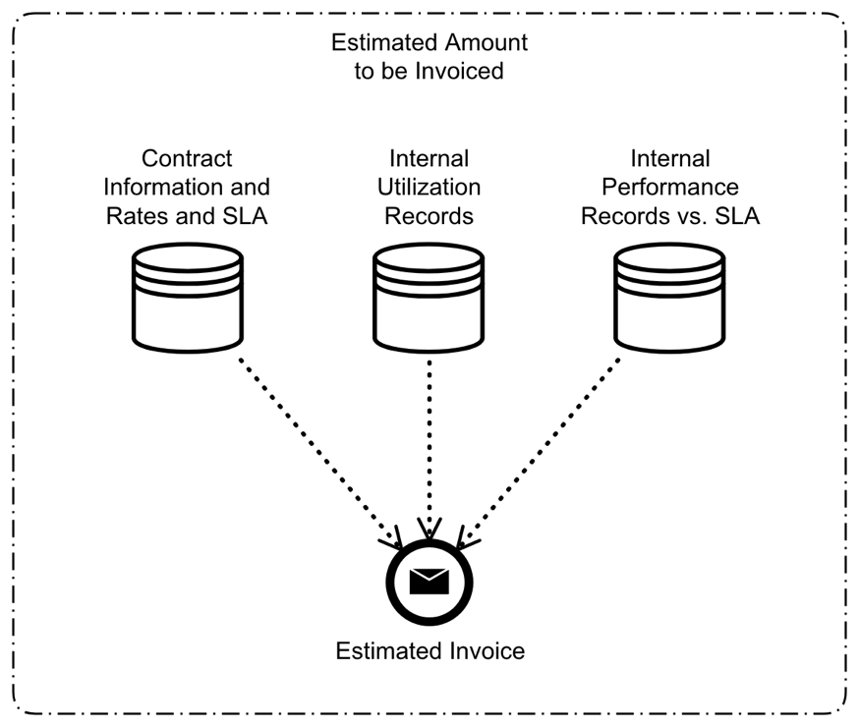
Figure 2: Estimating charges

8 Invoicing

8.1 Introduction to Invoicing
Invoicing is a process where the Seller is generating an Invoice and sending it to the Buyer.
A Seller in a Supply Chain invoices its Buyer for the services the Buyer has consumed. The invoice is based on an agreement between the Buyer and the Seller.
[D6] An agreement SHOULD be implemented using a smart-contract where applicable.

8.2 Invoicing occurrence
As discussed in clause 4.3.6 Frequency of Reconciliation and Settlement) above invoices are issued on interval or event-based as defined in an agreement between the Seller and the Buyer.
- Interval based invoices are generated on agreed upon intervals (e.g. Monthly, Quarterly, Weekly). Such invoices may include:
- Recurring charges for long-term services.
- Non recurring charges that represent once-off transactions that occurred between the previous and current invoicing cycles.
- Adjustments to previous invoices (e.g. debit or credit notes).
- Event-based invoices are generated when an event occurs (e.g. a Buyer places an order with a Seller for a once off service such as hardware or software upgrade).
[R11] A Seller SHALL invoice a Buyer on interval or event as per agreement between the Buyer and Seller.
[D7] Invoice generation SHOULD be triggered by a smart contract where applicable.

8.3 Invoice contents
[R12] An Invoice SHALL include the following information:
- Legal name of the Seller as stated in the agreement.
- Legal name of the Buyer as stated in the agreement.
- Date when invoice was issued.
- Description of goods and/or services covered in the invoice.
- The monetary amount of the invoice.
- Tax amount and respective tax type (e.g. VAT/GST) and amount (e.g. 21 %).
- The currency of the invoice.
- A unique ID/Number of the invoice.
- Any information or detail required by policy or regulation.
[O8] An invoice MAY include some or all of the following additional information:
- A detailed list of items included in the invoice.
- The monetary amount and currency of each item.
- A reference to an external record (e.g. exchange rate published by a specific bank, a specific DLT record).
- Due date of the invoice.
- Any other detail mutually agreed upon between the Buyer and the Seller.

8.4 Buyer-Seller entity multiplicity
For tax, legislative and trade purposes companies may have multiple commercial, operational and legal entities registered in different jurisdictions. Such entities may be grouped and operate as a single Buyer/Seller or may operate as independent entities. Each such entity has a unique legal name.
[O9] A Buyer and a Seller MAY each operate multiple entities.
[R13] An agreement between a Buyer and a Seller SHALL include one or more entities on each side.
[R14] An agreement between a Buyer and a Seller SHALL list all the entities, on both sides, it applies to.
[R15] When a Buyer places an order with a Seller it SHALL specify the Buyer's and Seller's legal entities involved with the specific order.
The above requirements, together with [R12], mandate that each pair pf Buyer-Seller entities is invoiced separately.

8.5 Additional requirements related to Invoicing in a PDL enabled environment
[R16] The Seller SHALL invoice in conformance with MEF 74 [i.1].
[D8] The Seller SHOULD keep a copy of the invoice in a PDL that has been established with the Buyer.
[R17] The Seller SHALL invoice based on contracted payment method (e.g. FIAT currency, crypto-currency or stablecoin) as agreed by both parties.
[R18] The Seller SHALL be able to generate printed originals or human-readable electronic versions of invoices if required to do so by the Buyer or by local regulations and/or legislation.
[D9] The notification of the Buyer about issuance of an invoice SHOULD be automated through a Smart Contract.
[O10] The invoice MAY include recurring charges, one-off charges, service credits based on SLA, penalties, refunds, discounts and taxes.
[R19] The inclusion of multiple charge items into a single invoice SHALL be agreed by the Buyer and Seller and abide by the respective regulations and or legislation.
[O11] SLA credits included in an invoice MAY be calculated on a per-service-instance basis or be aggregated in agreed-upon forms in conformance with MEF 74 [i.1].

9 Discrepancy and Dispute Management

9.1 Introduction to Discrepancies and Disputes
Discrepancies are differences between data/information held by two entities with relation to a specific item such as an invoice, a rate or a measurement. Discrepancies may be measured by the following metrics:
- Differences in the monetary value of a rate (e.g. Seller claims the rate is USD 1.05/mile and Buyer claims it is USD 1.03/mile thus the difference is USD 0.02/mile).
- Differences in measurements represented in units of measurement (e.g. Flow of data is measured in GB. The Seller claims the Buyer has used 2.5 GB of data and the Buyer claims they have only used 2.4 GB thus the difference in measurements is 0.1GB).
- Fractional difference between numerical values represented in percent or decimal notation (e.g. 1.05 divided by 1.03 yields a ~2 % discrepancy which can also be represented as a decimal fraction 0.02).
- Total Monetary value of the difference (e.g. Based on rate and measurements the Seller invoices an amount of USD 1,500 while the buyer claims that based on their own calculations, they only owe the Seller USD 1,300 thus the total monetary difference is USD 200).
[D10] Discrepancies and dispute management methods SHOULD be agreed between the Buyer and Seller and documented in a legal agreement.
[D11] In a PDL enabled environment such agreement SHOULD be implemented as a smart contract where applicable.
[R20] If the parties agree that there is no discrepancy, or if the discrepancy is below a defined threshold (see clause 9.2 Dispute Threshold herewith), the settlement amount SHALL be equal to the invoice amount.
[O12] If the Buyer determines that there is an actionable discrepancy, it MAY raise a dispute that triggers a dispute resolution process.
[O13] The dispute resolution process MAY be automated as per prior agreement between Buyer and Seller or it MAY be manual or a combination of the two.

9.2 Dispute Threshold
The dispute threshold is a value in an agreement between the Buyer and the Seller.
When the discrepancy is above the dispute threshold, the Buyer may trigger a dispute resolution process (see requirement [O12]), and conversely, when below the threshold, it will accept the invoice as-is.
EXAMPLE: The parties may agree that a discrepancy below 1 % is ignored, in which case when the discrepancy is below 1 % the Buyer will accept the invoice and not raise a dispute.
[O14] Thresholds MAY be combined.
EXAMPLE: The parties may agree that a discrepancy below 1 % is ignored unless the total monetary value of the discrepancy is above USD 500, in which case the Buyer may open a dispute even if the discrepancy (say USD 550 for the purpose of this example) is less than 1 % of the invoice value.

9.3 Dispute Resolution
The reconciliation and dispute resolution processes may vary depending on agreement between each pair of Buyer and Seller. The methods and algorithms of resolving a dispute are beyond the scope of the present document. The examples presented herewith are for demonstrative purposes only.
An example of dispute resolution logic:
- If discrepancy is lower than 1 % then no dispute.
- If discrepancy is between 1 % and 5 %, then take the arithmetic average between the values of Buyer and Seller.
- If discrepancy is higher than 5 % then defer to manual (case-by-case) dispute resolution.
Another example may be similar to the above with the exception that for the case of a discrepancy between 1-5 percent the settlement value is calculated using heuristics based on previous settlements in a manner that removes bias caused by one party consistently reporting values in its own favour.
[O15] Subject to contract the parties MAY agree to perform partial reconciliation and settle some of the pending invoice/invoices while continuing reconciliation of others.
[D12] Dispute thresholds and resolution SHOULD be implemented by a smart contract where applicable.
[R21] If a dispute is triggered by Buyer or a Seller, it SHALL be resolved either (a) manually, (b) automatically or (c) through a mix of both.

9.4 Finality
The end result of the reconciliation process is final and binding to both parties.
[R22] Upon completion of the Reconciliation process, a final and binding mutually-agreed-upon amount SHALL be settled between the Buyer and the Seller.
[R23] If an invoice has already been issued and it differs from the final amount agreed by the parties, a credit note or a debit note SHALL be issued by the Seller to cover any differences.
[R24] In a PDL enabled environment the final invoice and any credit and debit notes SHALL be recorded on to the PDL.

10 Settlement

10.1 Definition of Settlement
Settlement is the transfer of monetary funds between parties based on invoicing and reconciliation.

10.2 Payment
Upon completion of reconciliation and issuing a final invoice and/or any credit/debit notes the parties settle through payment of the agreed upon amount between the parties.
[R25] The payment SHALL take form of one of the following: (a) transfer of a fiat currency through legacy means (bank transfer, cheque), (b) an electronic transaction of a stablecoin (a crypto-currency whose value is pegged to a fiat currency) or (c) a crypto-currency transaction.
[R26] The form of payment and the currency/currencies used for payment SHALL be agreed upon by both parties in the contract.
[R27] Payment SHALL be made in accordance to the terms stipulated in the agreement.
[R28] Payment SHALL comply with all regulatory requirements by the jurisdiction(s) where the Buyer and the Seller are established.

10.3 Netting
Netting is the act of subtracting the amounts due by two parties to each other. If the parties have reciprocal services (both buy and sell with each other) the settlement may include netting of pending amounts where the actual amounts being transferred will be the net amount. In such event the pending amount of one party is subtracted from the pending amount of the other party and only the net amount, after such subtraction, is being transferred from one party to the other.
Net Amount = (amount owed by A to B) - (amount owed by B to A)
If (amount owed by A to B) > (amount owed by B to A) A pays Net Amount to B, otherwise B pays Net Amount to A.
[O16] If two parties have a reciprocal trade, they MAY net their invoices as part of the settlement process.
  - [O16] In a PDL enabled environment the Netting SHOULD be recorded in a PDL where applicable.

10.4 Netting and Payment process diagram
Figure 3 illustrates the Netting and Payment process flow.
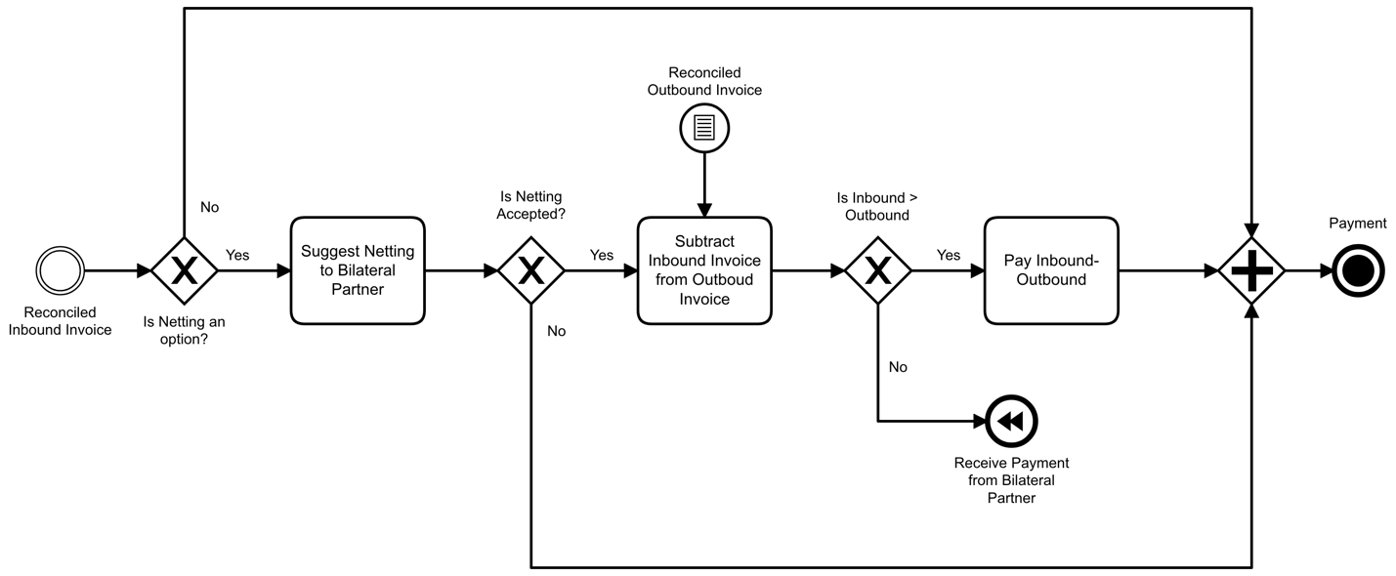
Figure 3: Payment and Netting process flow

Annex A (informative):
Change history
Date | Version | Information about changes
<Month year> | <#> | <Changes made are listed in this cell>

History
Document history
V0.0.6 | March 2024 | Clean-up done by editHelp!  E-mail: mailto:edithelp@etsi.org

